**GLOBAL OBJECT:-**

* In node js instead of “window” object we have “**global**” object. Means “global” will be prefixed everywhere.
* Anything defined in a “module” is not a part of “global” object.
* Each file in node is a module and variables and methods defined in that module is scoped to that module only.

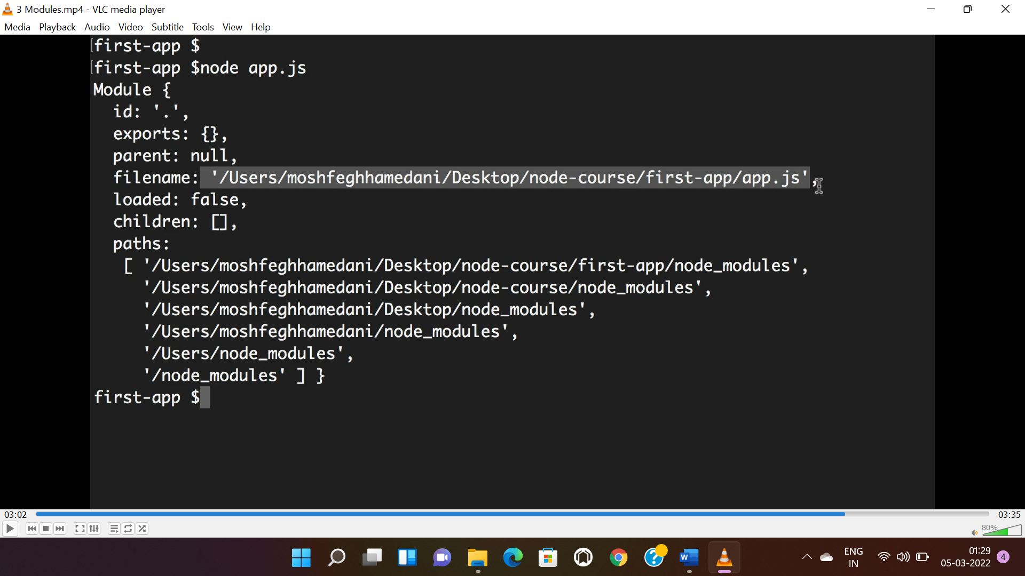

**EXPORTING A MODULE:**

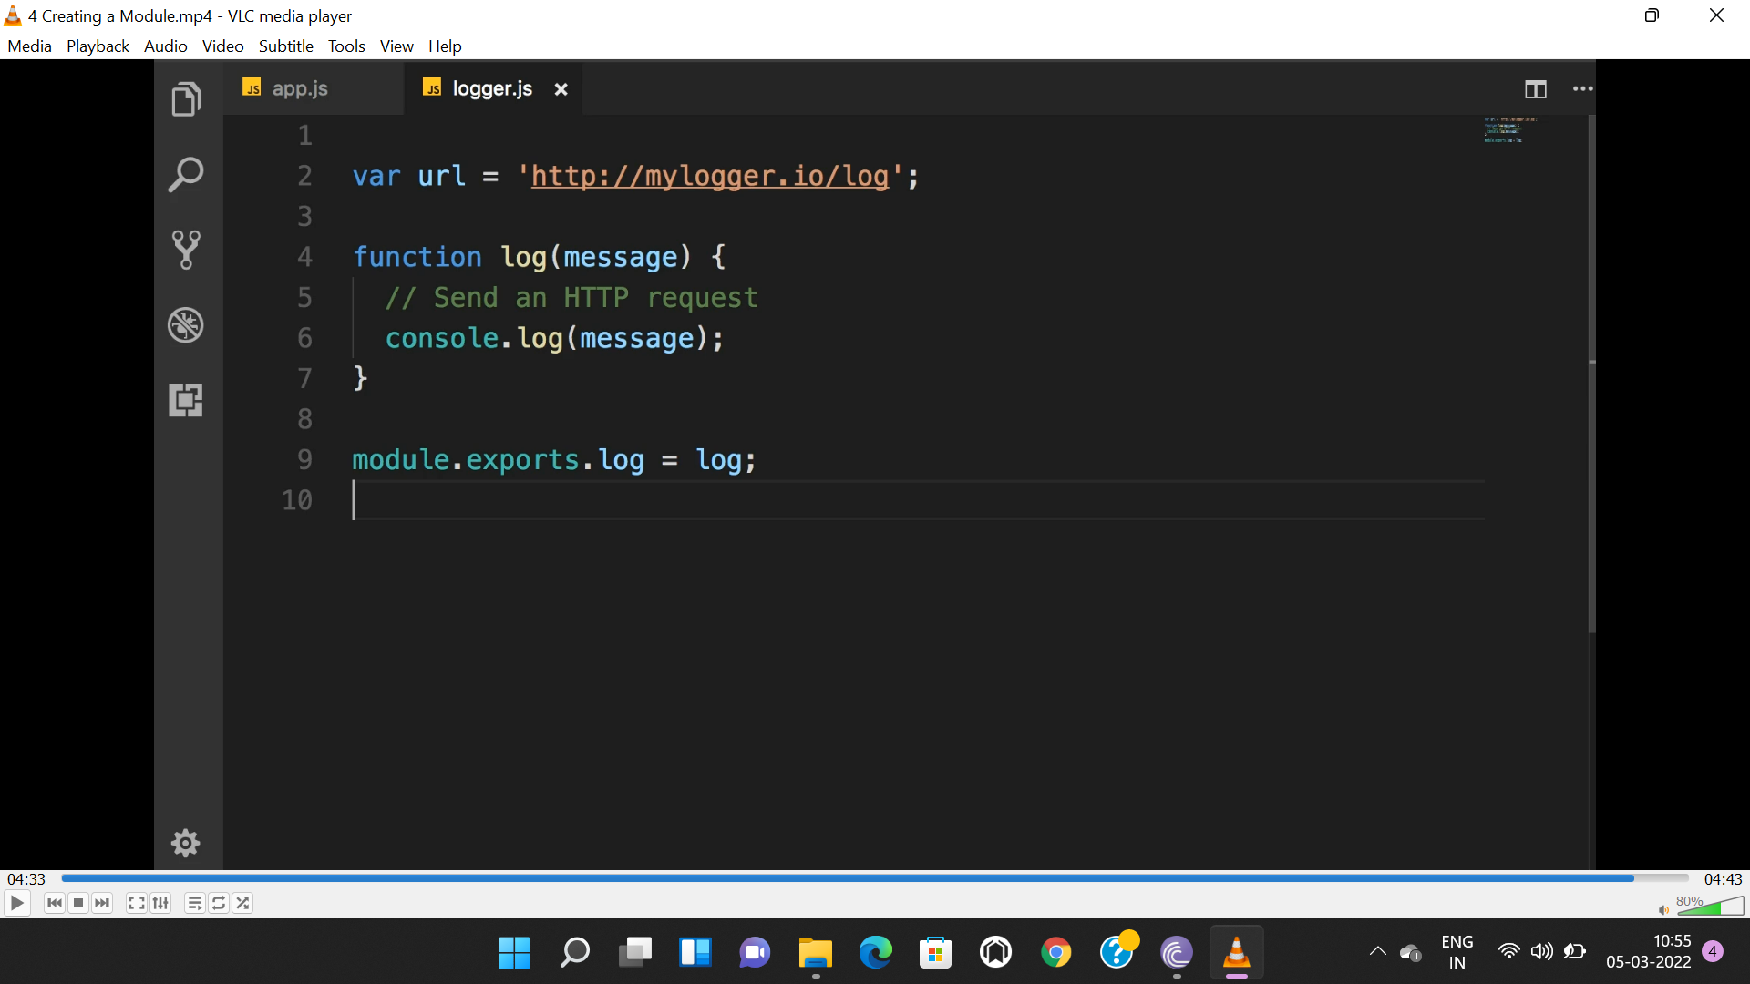

**IMPORTING A MODULE:**

* **“require()”** method id required to import a module.

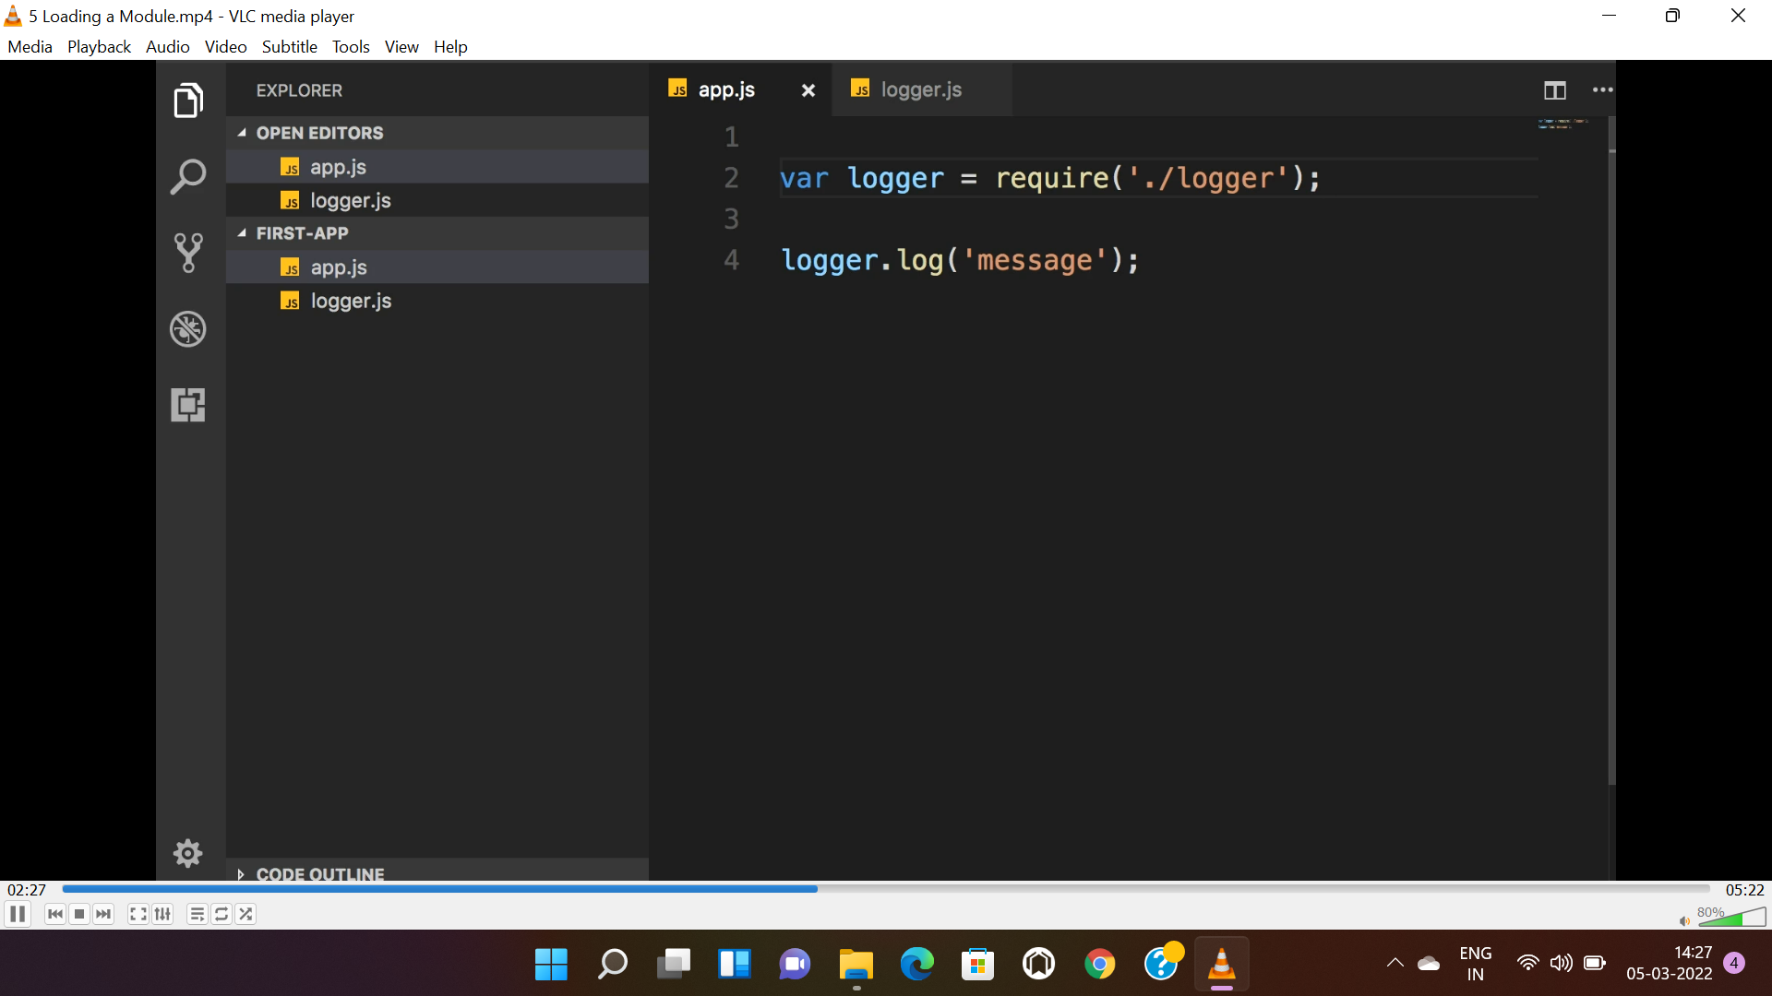

**WRAPPER FUNCTION:**

* Every module is wrapped by a wrapper function.
* All the parameter of wrapper function is available to all modules.

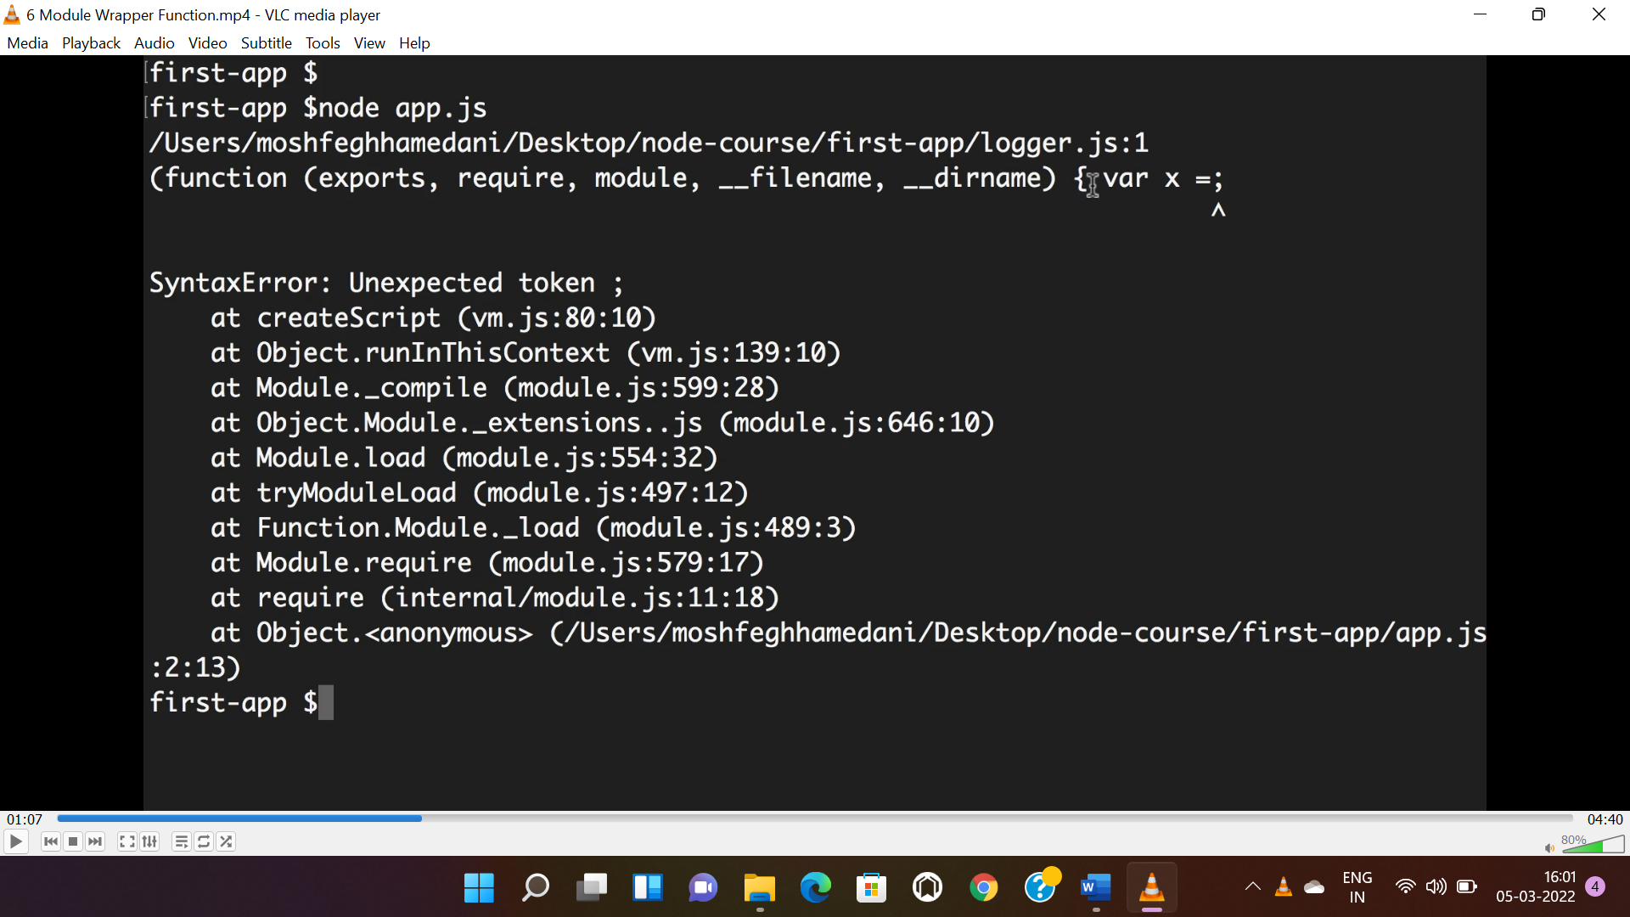

* Require = used to import
* Module = ref of module object
* Exports = used to export
* __filename = file name
* __dirname = folder name

**PATH MODULE:**

* Used to read path of a module.
* “**parse()**” method used to read path of filename.

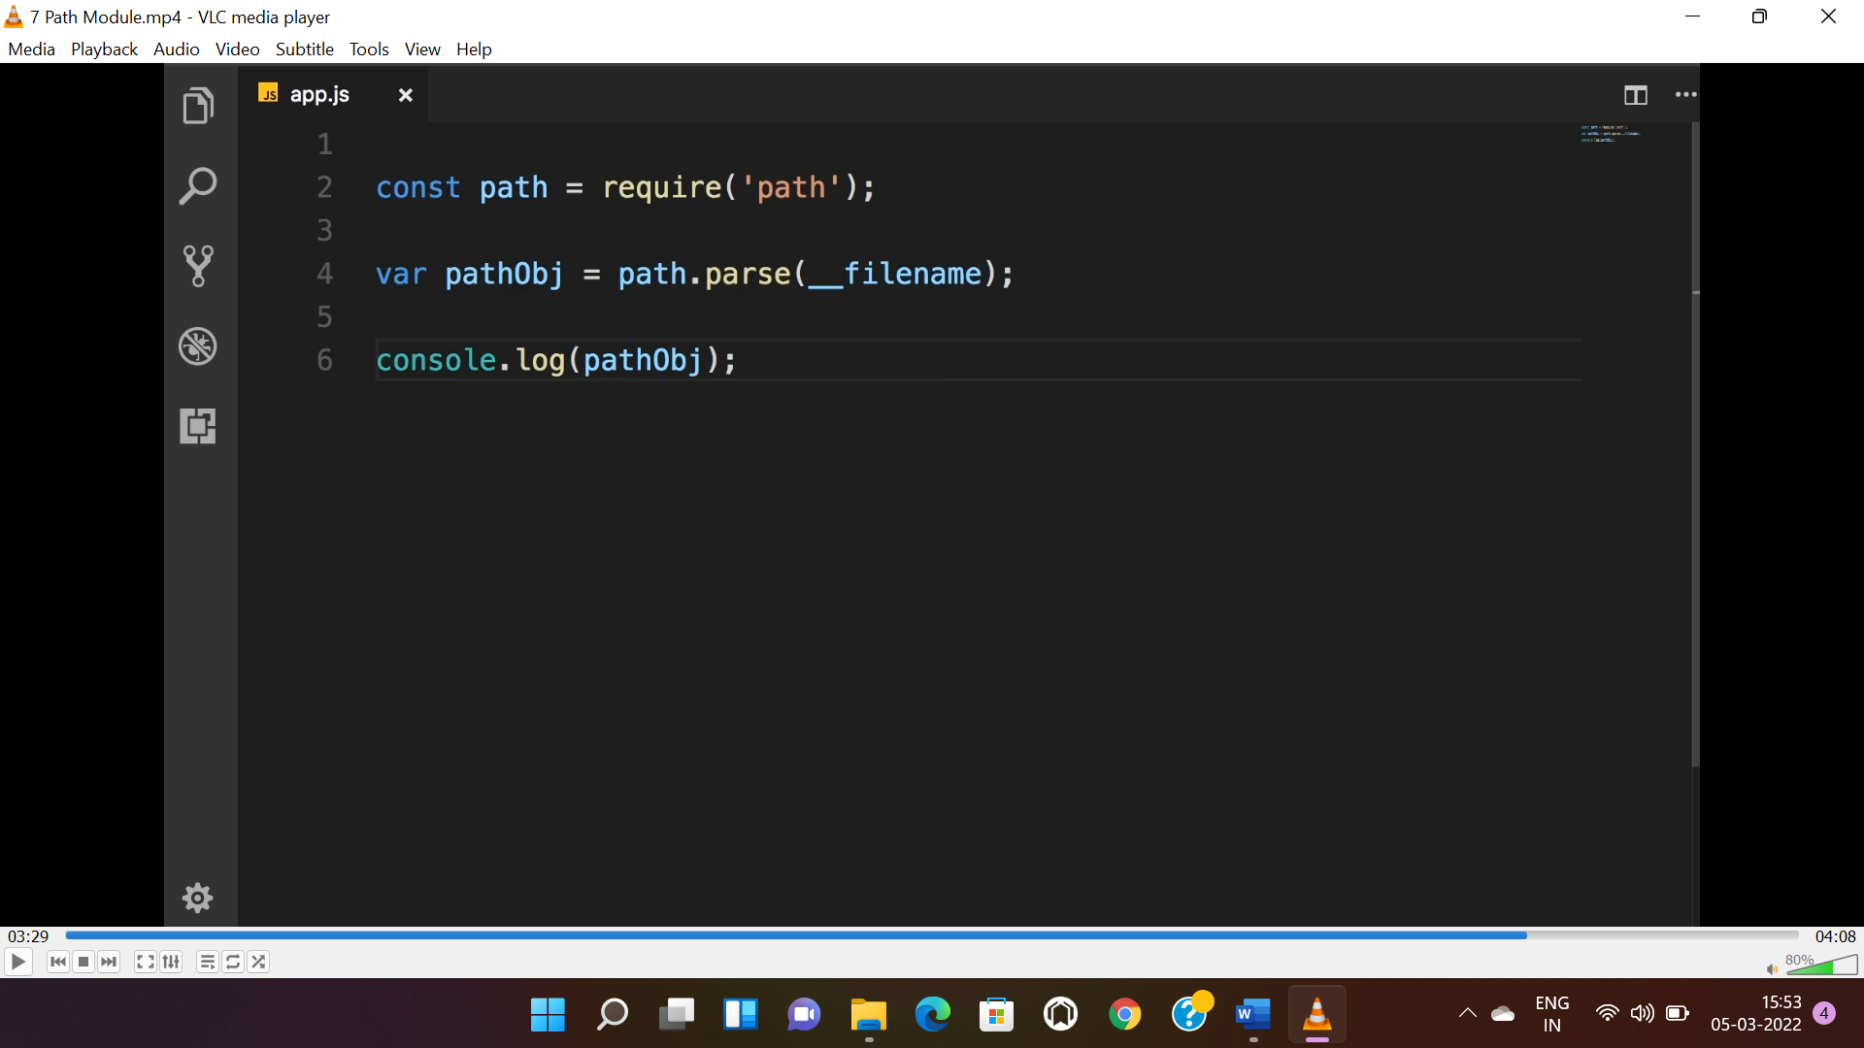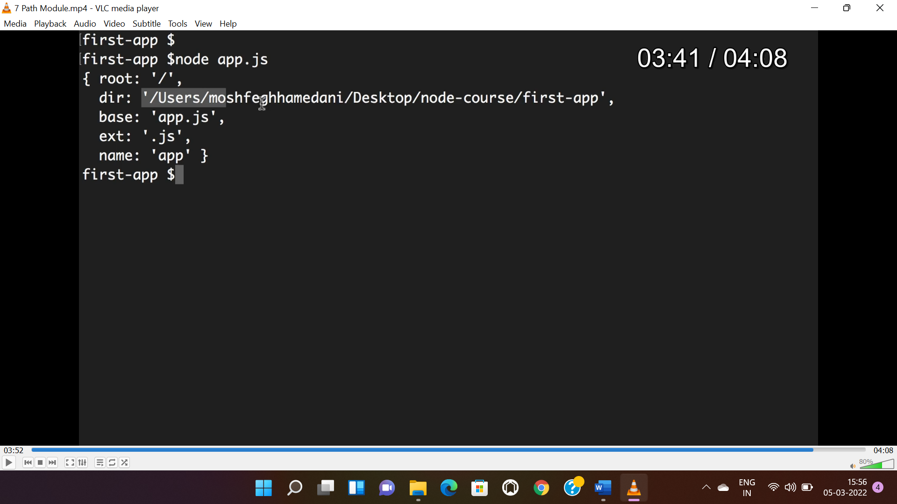

**OS MODULE:**

* Used to get details of OS like total memory, free memory etc.

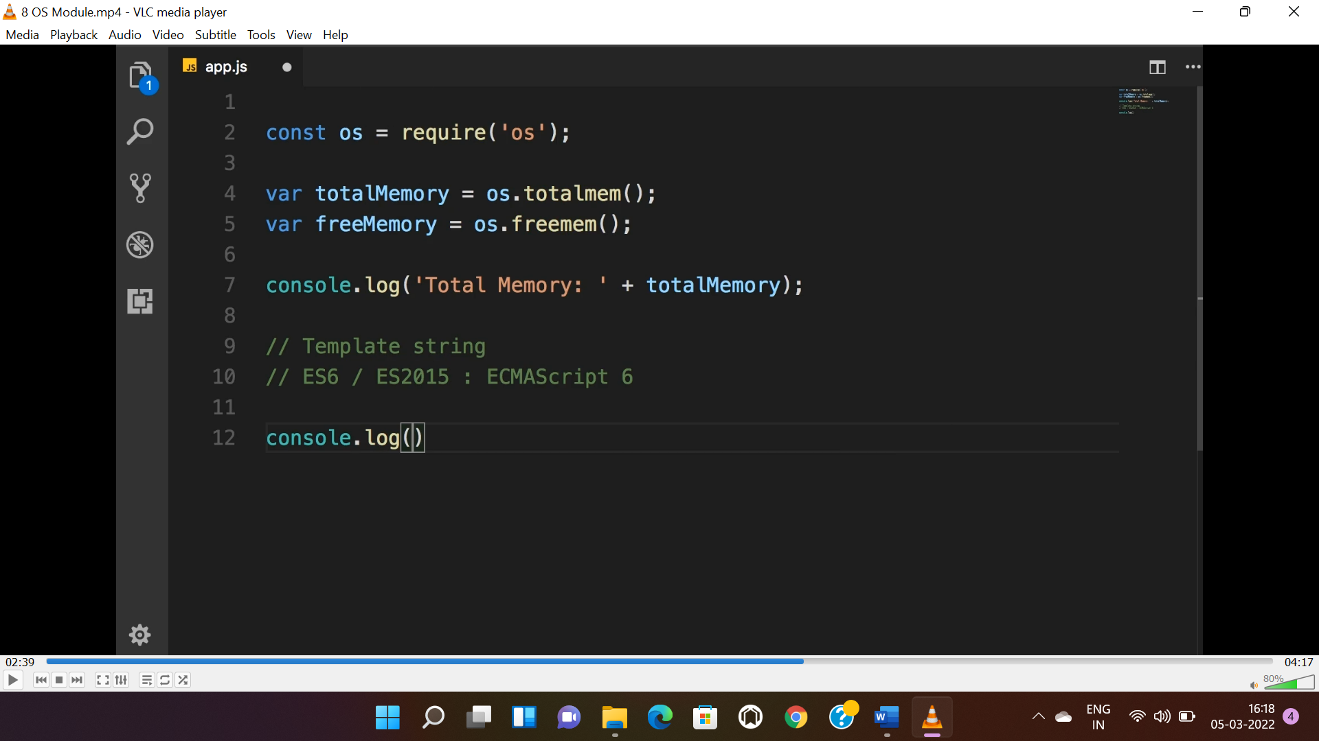

**FS MODULE:**

* Used to access file system.
* Async method always preferred instead sync method.

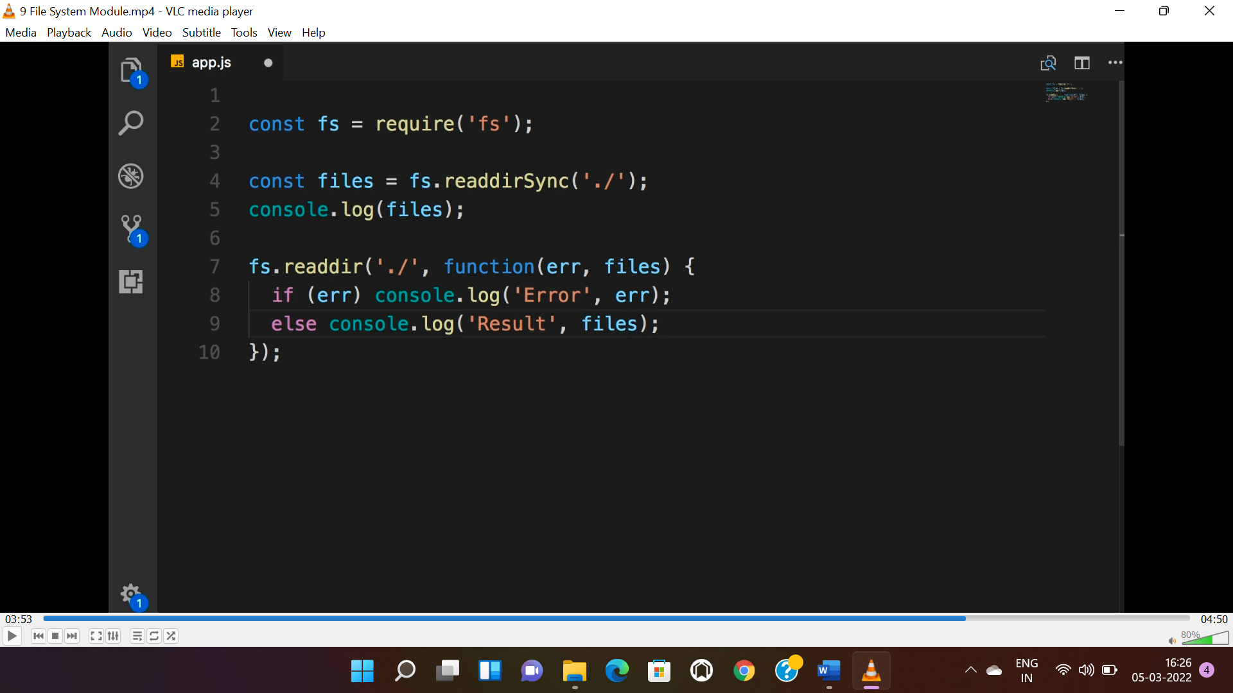

**EVENT MODULE:**

* “**event**” is a class imported using “**EventEmitter**” .
* Object need to be created to use the class.
* Used to raise events using “**emit()**” method.
* The order is 1st listener to the event to be defined using “**on()**” or “**EventListener()**” method then event need to be raised.

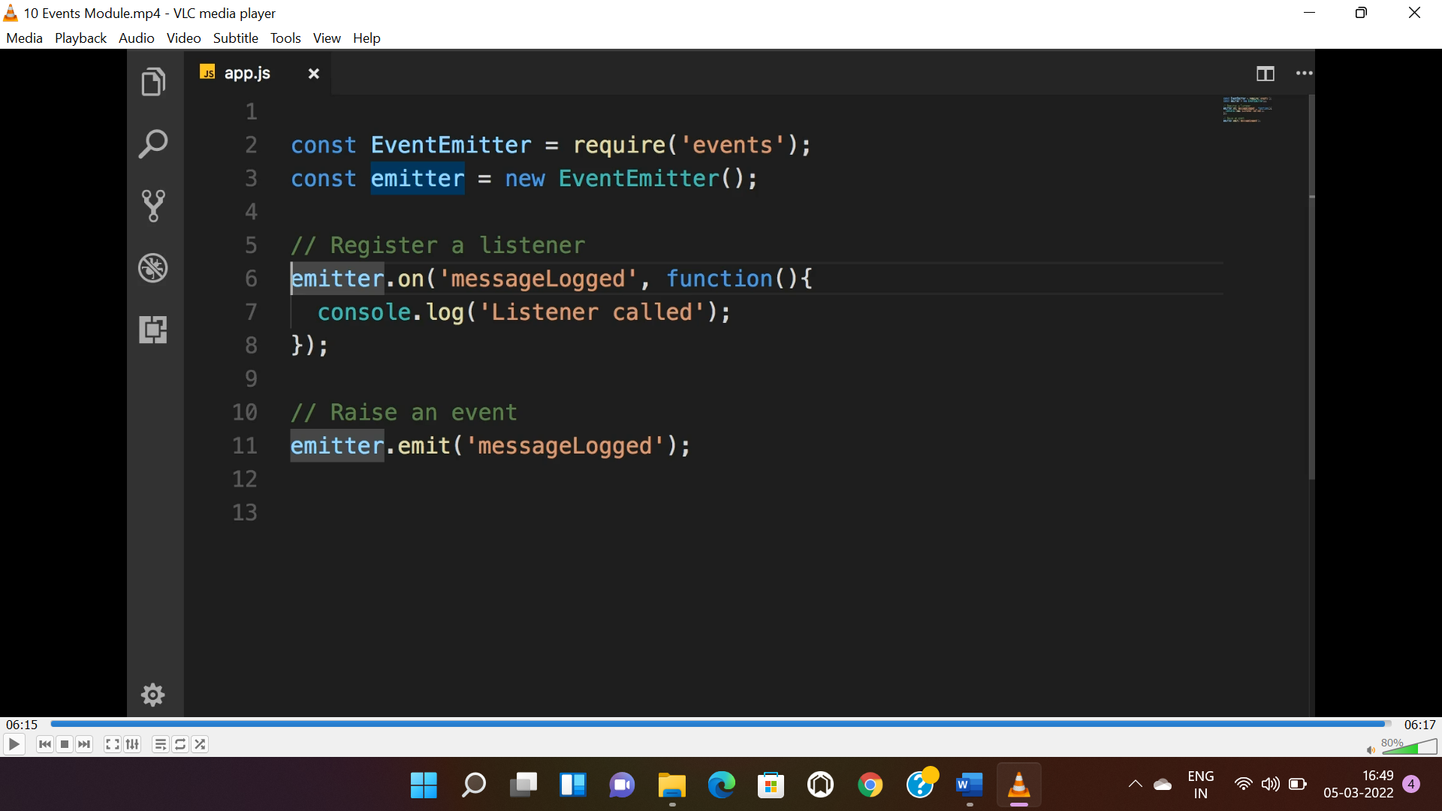

* We can also pass arguments through “**emitter**”, to pass the args we need to pass that data as a 2nd parameter in “**emit()**” method.

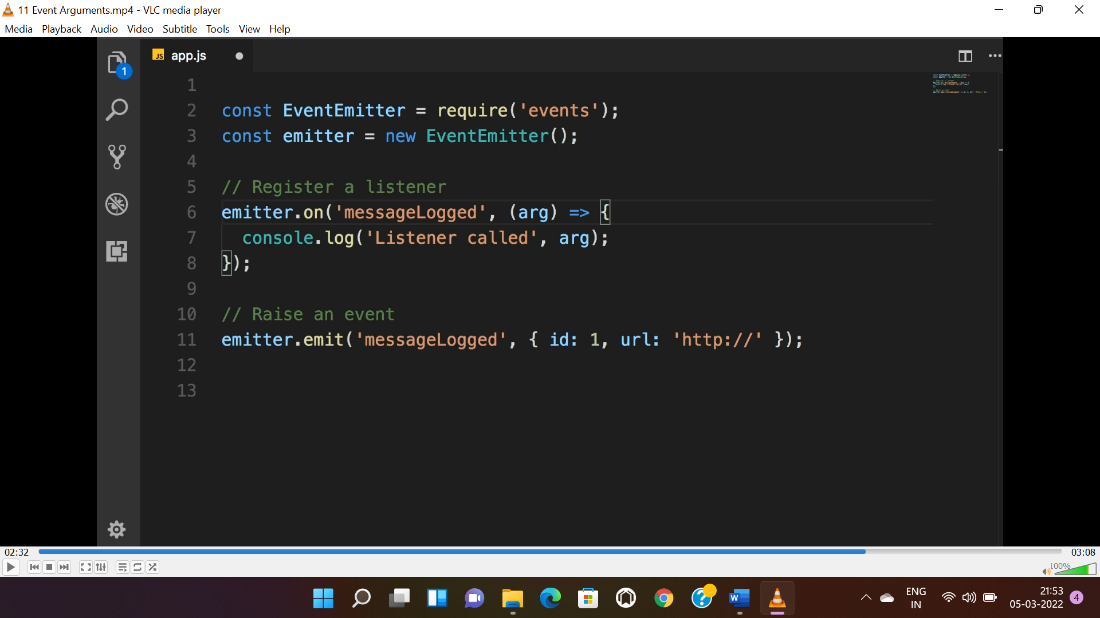

**EXTENDING EVENT EMITTER USING CLASS:**

* Instead of creating instance of “**EventEmitter**” we can create a class that extends “**EventEmitter**” with extra functionality of logging message i.e we can integrate the ‘’**emmit()**” method dynamically as well.

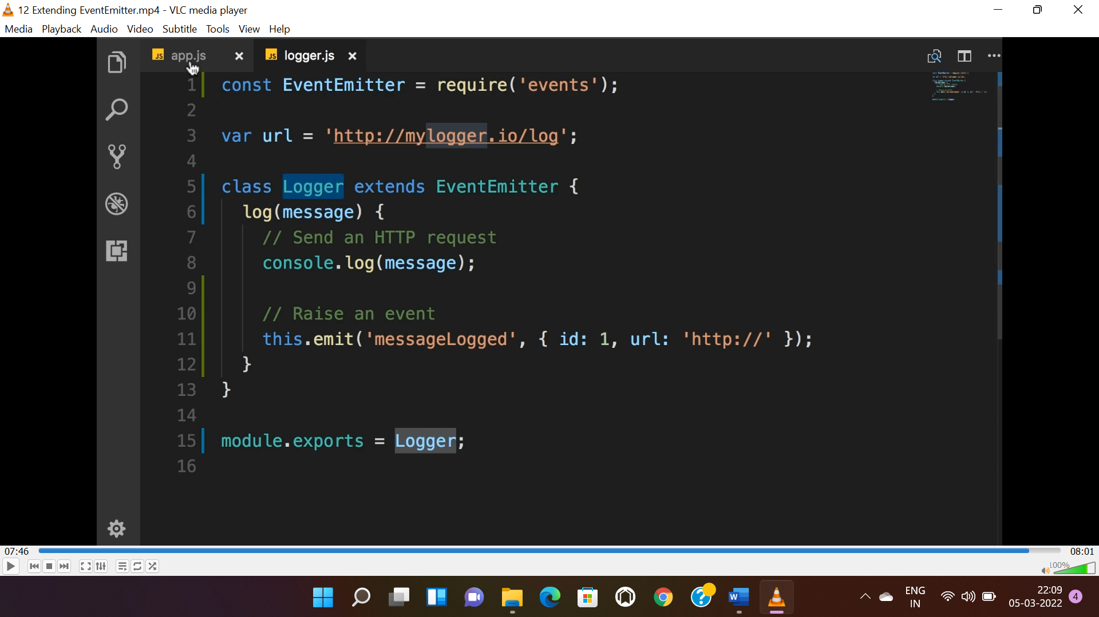

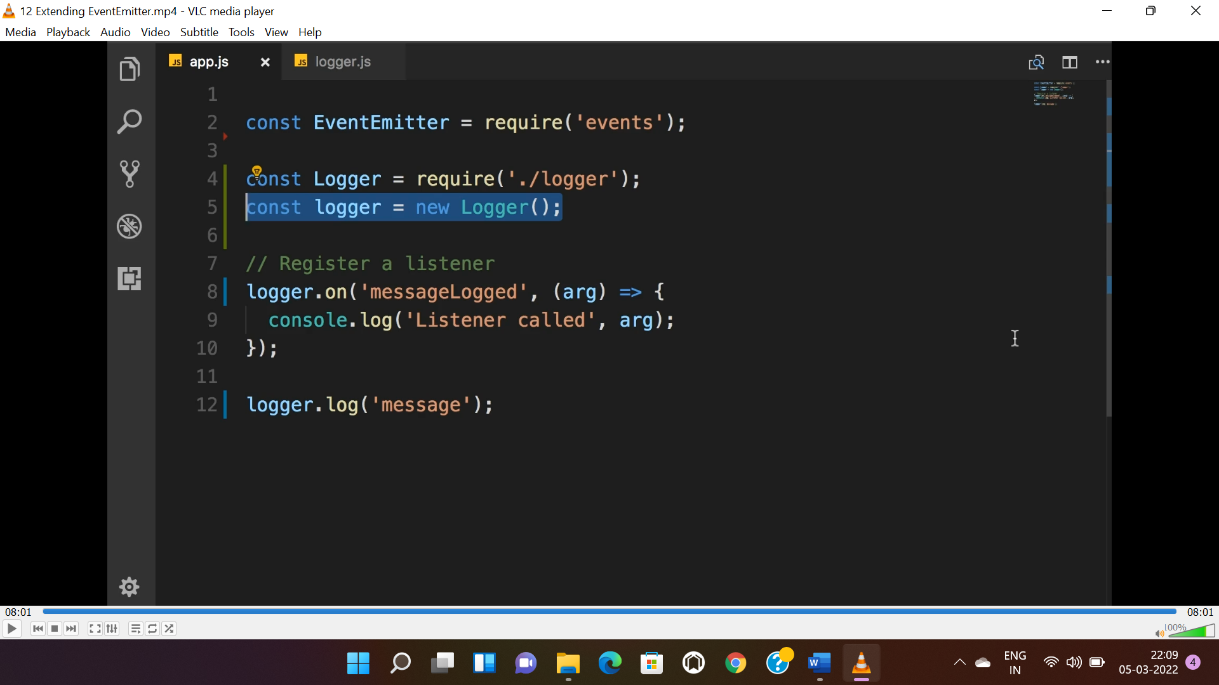

**HTTP MODULE:**

* This module is used to create web server using “**createServer()**” method.
* This module also have the functionality of “**EventEmitter**”.

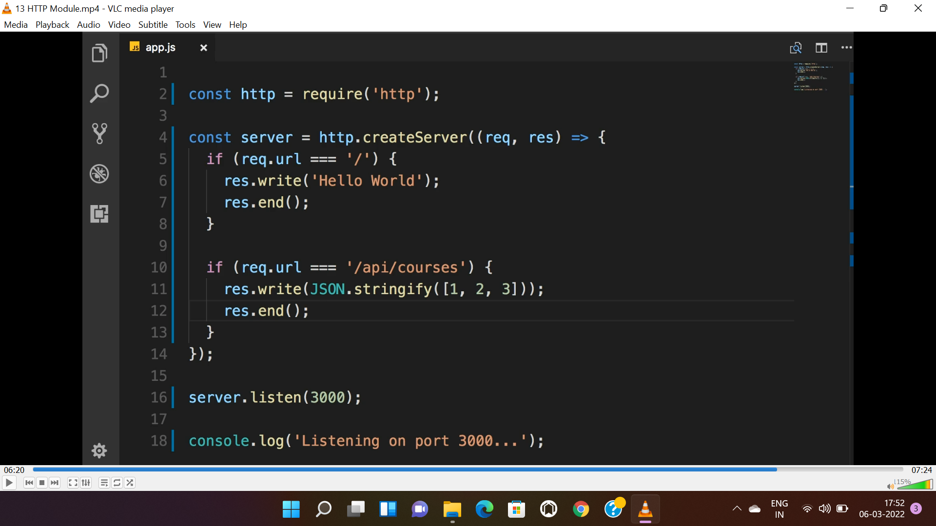

**NPM OR YARN:**

* “**^**” indicated fixed major version and any minor and patch version, alternate is 1.x
* “**~**” indicates fixed major and minor and any patch version, alternate is 1.2.x
* To know all the dependencies command is “**npm list / yarn list**”.
* To know only parent dependencies command is “**yarn list --depth=0**”
* To view all versions “**yarn view package_name versions**”
* To install global packages “**yarn install -g**”